## User Interaction & Outputs

In this lecture we are going to add an input form to our joke application so the user can add their own jokes to the list.

**Learning Outcomes**

* How to emit custom output events from components.
* How to create local variables in the templates.

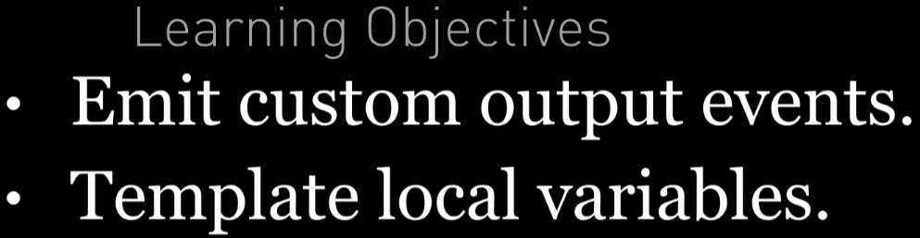

**The Joke Form**

We *could* add a form in our JokeListComponent it would definitely be easier to setup since all the code would be contained in one component.

However we are going create a new component to support the form, perhaps we want to re-use this form in other places in our application or perhaps we want this functionality in one component so it’s easier to test in isolation later on.

This component renders a bootstrap form on the page with two fields, setup and punchline, and a Create button.

When architecting an Angular application I often find it helps to first think about ***how*** your component is going to be used rather than how you are going to build the component and what it is going to contain.

I believe our form component is best placed in the JokeListComponent template, like so:

<

joke-form

①

(jokeCreated)="addJoke($event)">

②

<

/joke-form

>

<

joke *ngFor="let j of jokes" [joke]="j"></joke

>

1. The components tag, its selector, is going to be joke-form.
2. The component should have an output event(jokeCreated). The component is going to emit an event called jokeCreated whenever a user clicks the Create button.

We treat the component as a black-box, we don’t care *how* the component is

implemented or how the user interacts with it. The parent component just wants to know *when* the user has created a new joke.

When the jokeCreated event is emitted I want to call the addJoke function.

 We’ll go through what $event means a bit later on in this chapter.

The above syntax describes the behaviour we expect from our JokeFormComponent, lets now go and create it.

**The JokeFormComponent**

The component renders a twitter bootstrap formatted form with two fields and a submit button, like so:

@Component({

selector: 'joke-form',

template: `

<

div class="card card-block"

>

<h4 class="card-title">Create Joke</h4>

<div class="form-group">

<input type="text"

class="form-control"

placeholder="Enter the setup">

</div>

<div class="form-group">

<input type="text"

class="form-control"

placeholder="Enter the punchline">

</div>

<button type="button"

class="btn btn-primary">Create

</button>

<

/div

>

`

})

class JokeFormComponent {

}



Remember to add

JokeFormComponent

to the declarations on the

NgModule

.

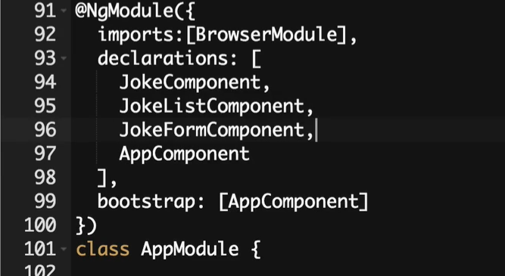

The component above just renders a form on the page, nothing happens when you click submit.

From the outside, all we really care about this component is, that it makes it available an output event binding called jokeCreated.

To create a custom output event on our component we need to do two things:

1. We need to create a new property called jokeCreated and this will be an instance of EventEmitter. EventEmitter is a helper class which we can use to emit events when something happens. And the components can then bind and react to those events. To use this we need to import it from angular/core. Create an EventEmitter property on the JokeFormComponent class.
2. Similar to when we created a custom input property binding, we need to annotate that property with the @Output decorator.

 An EventEmitter is a helper class which we can use to emit events when something happens, When something happens, other components can then bind and react to these events.

import {Output, EventEmitter} from '@angular/core';

.

.

.

class JokeFormComponent {

@Output() jokeCreated = new EventEmitter<Joke>();

}

We have now created an output event property on the component.

The name between the <> on the EventEmitter is the type of thing that will be

output by this property. The syntax above is called generics and we’ll cover them in more detail on the section on TypeScript.

When the jokeCreated event fires we are going to pass out an instance of a Joke.

We are initialising the property when it’s defined, in one line. Previously we just

declared the properties and initialised them in a constructor. The method you choose is up to you, with situations like this when the property will never need to change over time I like to initialise and declare on one line.

To support the event, Lets now create a function called createJoke() and have it actually output an event, like so:

class JokeFormComponent {

@Output() jokeCreated = new EventEmitter<Joke>();

createJoke() {

this.jokeCreated.emit(new Joke("A setup", "A punchline"));

}

}

We output an event by calling the emit function on our jokeCreated property. Whatever we pass to the emit function is what will be output by the property. We are outputting an instance of a Joke with some dummy data.

### Gluing it all together

We need to call the createJoke function when the user clicks the Create button, like so:

<

button type="button"

class="btn btn-primary"

(click)="createJoke()">Create

<

/button

>

Although, I written on how our joke form component is consumed in our joke list component. We actually need to implement the addJoke function, We also need to *bind* to the output event property(jokeCreated) on our parent JokeListComponent so we can add the joke that gets output to the list of jokes, like so:

@Component({

selector: 'joke-list',

template: `

<

joke-form (jokeCreated)="addJoke($event)"></joke-form

>

<

joke *ngFor="let j of jokes" [joke]="j"></joke

>

`

})

class JokeListComponent {

jokes: Joke[];

constructor() {

this.jokes = [

new Joke("What did the cheese say when it looked in the mirror?", "Hello-me

(

Halloumi)"),

new Joke("What kind of cheese do you use to disguise a small horse?", "Mask-a-

pony (Mascarpone)"),

new Joke("A kid threw a lump of cheddar at me", "I thought

‘

That

’

s not very

mature

’

"),

];

}

addJoke(joke) {

this.jokes.unshift(joke);

}

}

Breaking this down, in the template we bind to the jokeCreated property like so:

<

joke-form (jokeCreated)="addJoke($event)"></joke-form

>

This calls the addJoke function when the jokeCreated property outputs an event.



$event

is a special variable and holds whatever was emitted by the jokeCreated

EventEmitter, in our case its an instance of a Joke.

addJoke(joke) {

this.jokes.unshift(joke);

}

Our adddJoke function pushes a joke into to the front of the jokes array. All the addJoke function does is add the joke that got output to the front of the jokes array.

Angular automatically detects that the jokes array changed and then updated the view so it shows the new joke.

Now when we click the Create button we add the joke to the list, but it’s just showing the dummy fixed joke.

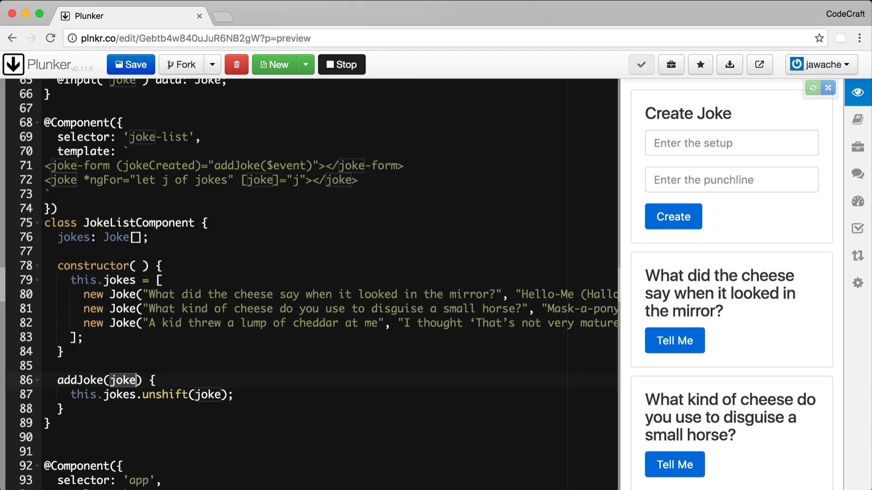

**Template Reference Variables**

So we’ve got the mechanism we are going to use to send events from our custom form control, how do we actually get the values from the input fields?

We want to actually get the value of the setup and punchline input fields and pass them to the createJoke function when the user clicks the Create button.

One way we can solve this problem in Angular is to use something called a template reference variable.

We add the string #setup to our setup input control, like so:

This # sign syntax is this is a template reference variable.

<

input type="text"

class="form-control"

placeholder="Enter the setup"

#setup>

This tells Angular to bind this <input> control to the variable setup and this is the default behavior of the template reference variable. In the forms section, we will know about how template ref. variables can be used to bind to different things.

We can then use this variable setup in other places in the template.

setup is only available as a variable in the template, we don’t automatically see the variable setup inside the javascript code of our JokeFormComponent class.

setup now points to the DOM element that represents an <input> control, which is an instance of the type HTMLInputElement.

Therefore to get the value of the setup input control we call setup.value.

We do the same to the other punchline input control, then we can pass both the setup and punchline values to the createJoke function, like so:

<

button type="button"

class="btn btn-primary"

(click)="createJoke(setup.value, punchline.value)">Create

<

/button

>

Finally we change the createJoke function so it accepts these new arguments and uses them to construct an instance of a Joke, like so:

createJoke(setup: string, punchline: string) {

this.jokeCreated.emit(new Joke(setup, punchline));

}

Now when we run the application the user can add a new joke via the form and have it appear in the list below.

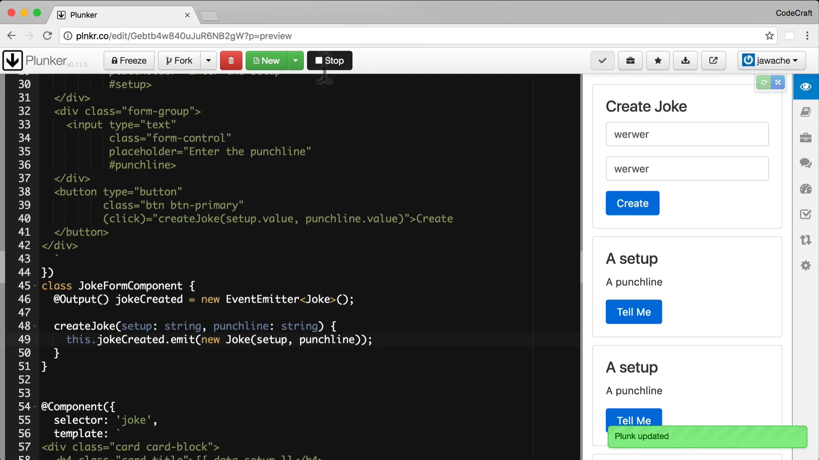

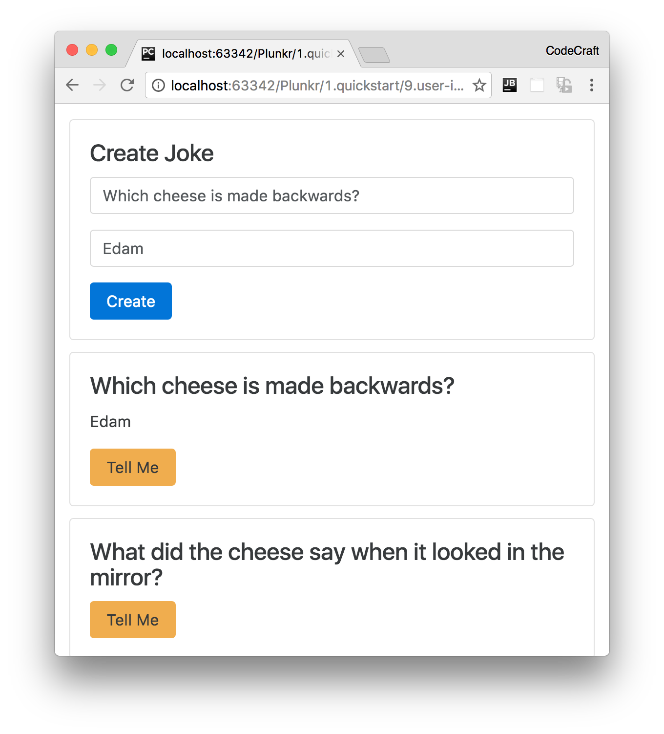

**Summary**

Similar to input properties, we can also create output properties on our custom components using the @Output annotation.

These **output properties are always instances** of the EventEmitter class and we output events by calling the emit function. **Whatever we pass in to the emit function is output as the $event template variable**.

We can create local template variables by adding variables starting with the # character on any element in our template.

By default that variable is only visible in the template that it’s declared in and points to the DOM element it’s attached to.

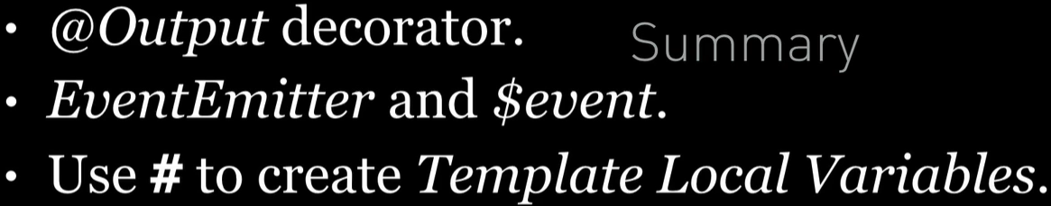

**Listing**

<http://plnkr.co/edit/v3vmZkOK4fxDXsrziqHx?p=preview>